CS 340 Project Two README

About the Project/Project Title
This Project displays all the available animals from the animal shelters, as well as age upon outcome, their ID, animal type, breed, color, Date of Birth, etc. The data table can be filtered by Rescue type which is water, mountain or wilderness, and Disaster or Individual Tracking. The table can be reset with the reset feature, and the column can filter data with their filter feature. You can select a specific animal and have their location displayed, their name, and animal type. The preferred animal and geolocation chart both updates based on the filter type selected.

Getting Started
Get started by ensuring Python3 and MongoDB are accessible. Download the required files and ensure the port being used at the bottom of the ipynb file is not being used somewhere else. Finally run the file and a link should redirect you to the application.

Installation
Python3, MongoDB access, and a python IDE are required to use the software. Jupyter is the IDE that the software is native to.

Usage

Code Example
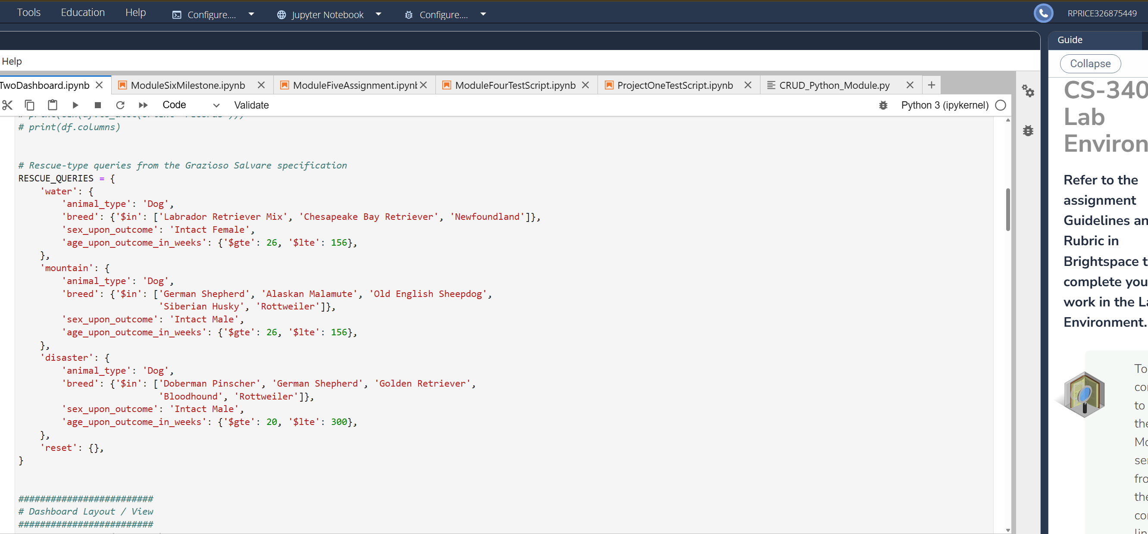

Screenshots

Water rescue filter functionality
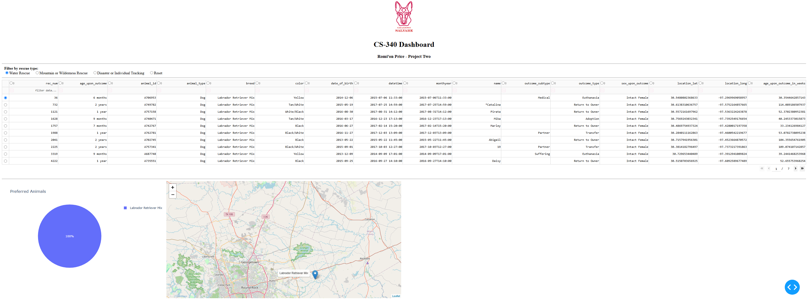
Mountain or Wilderness rescue filter functionality
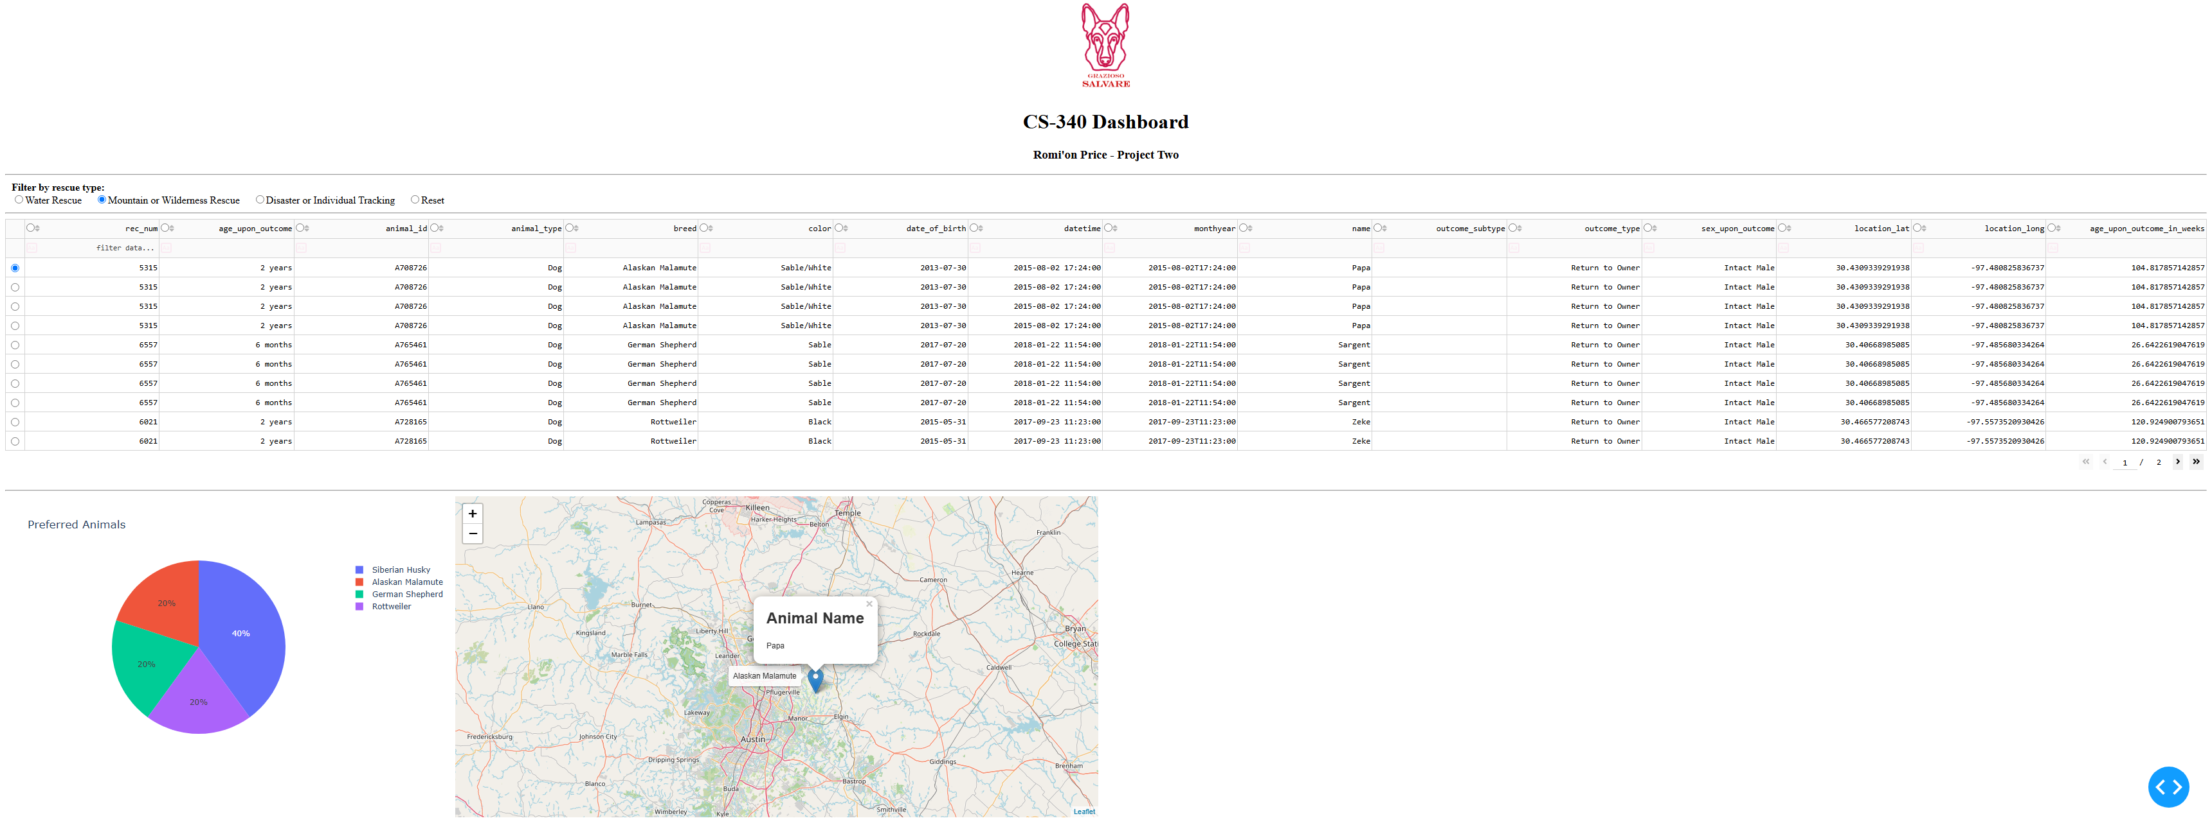

Disaster or Individual Tracking filter functionality
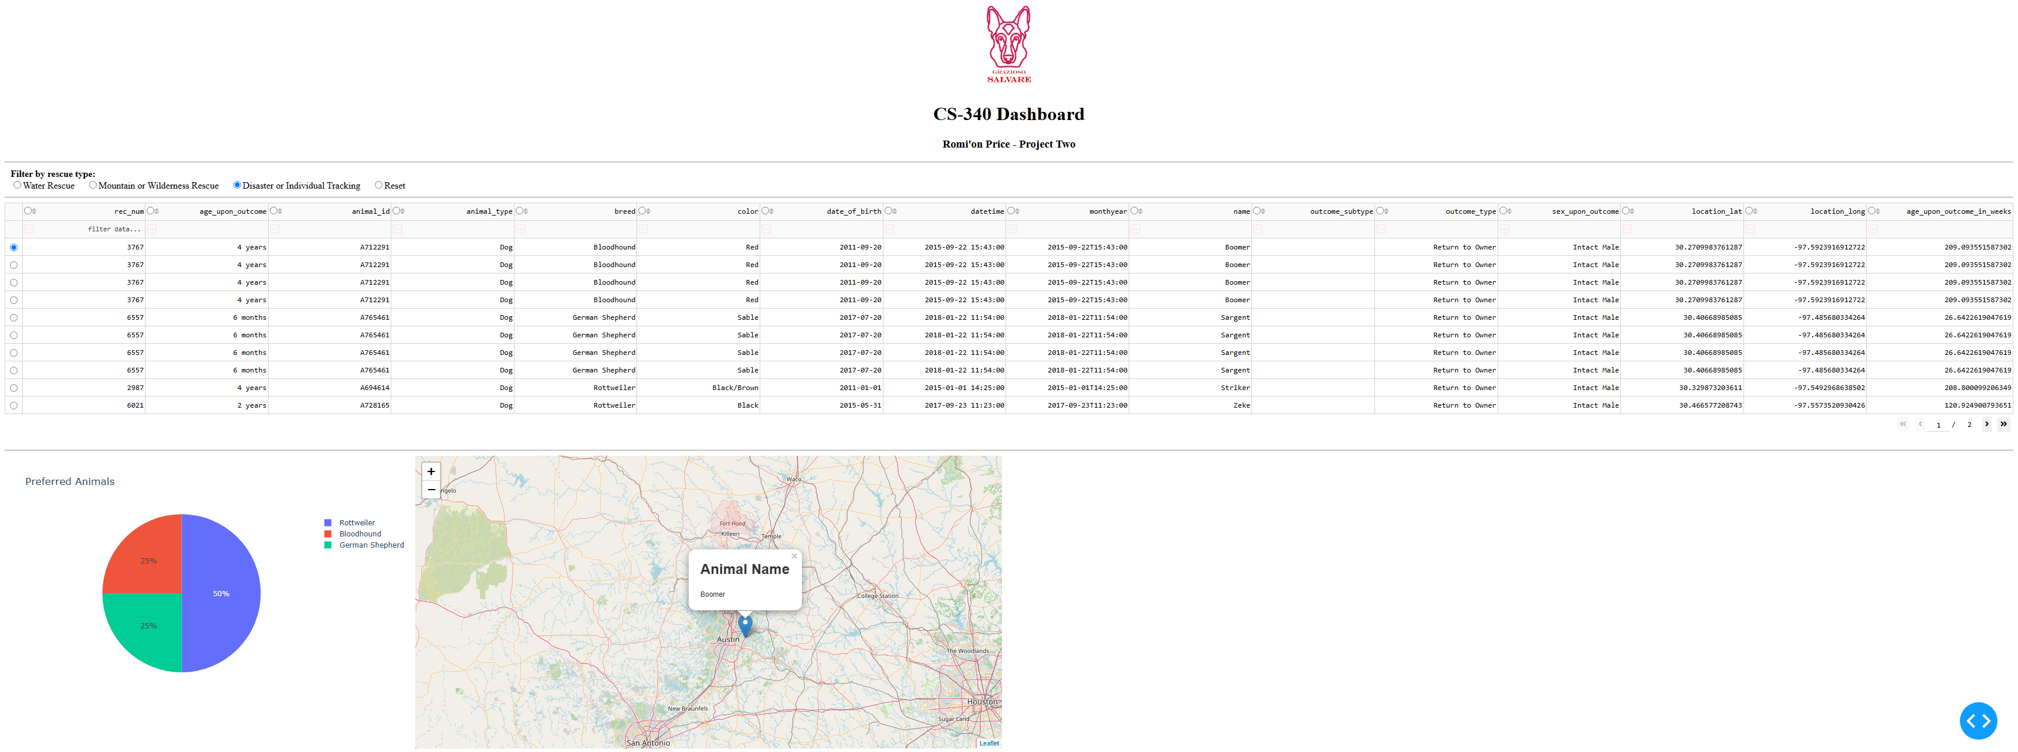
Highlight for column and cell functionality
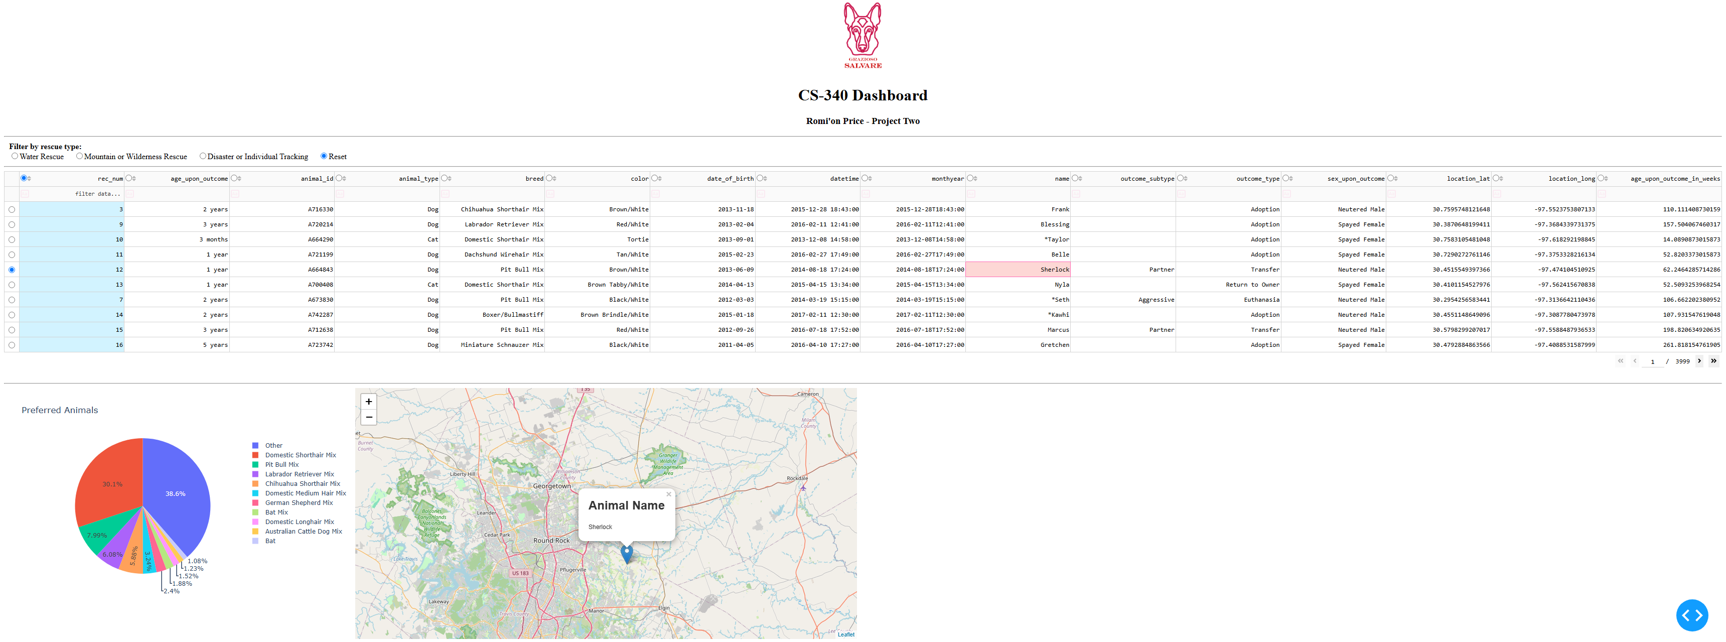

Column filter functionality
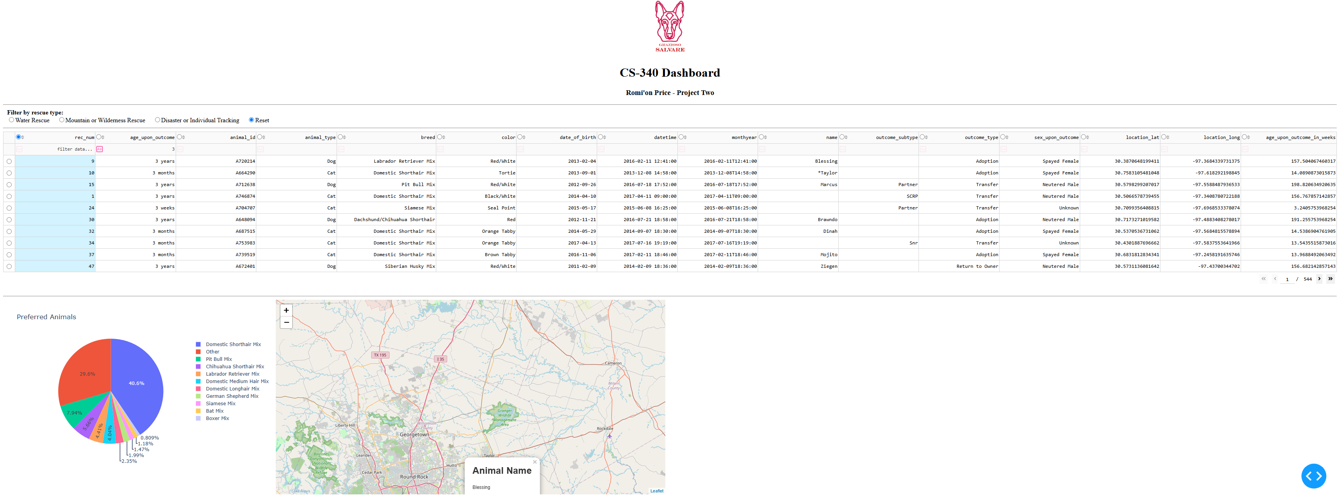
Reset feature returning widgets to original state
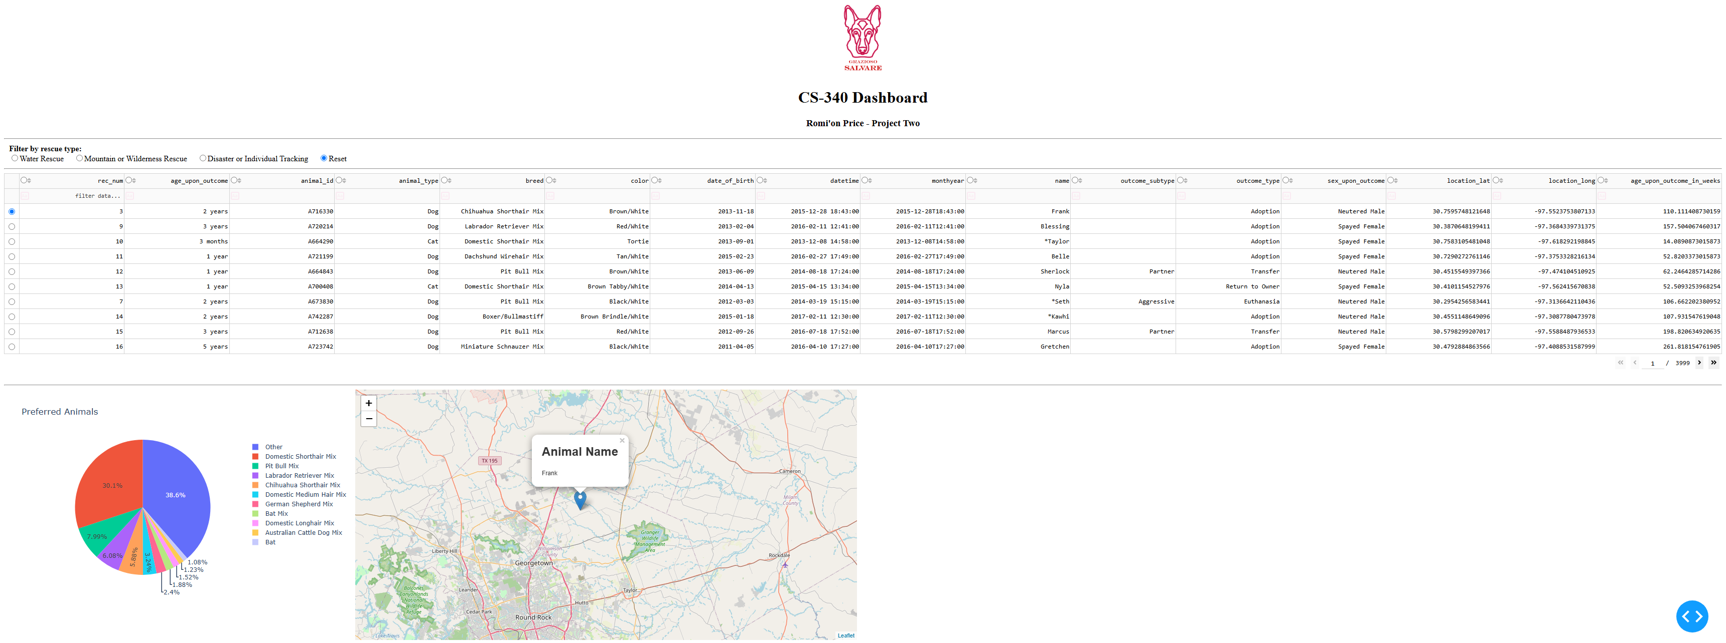
Describe the tools used to achieve this functionality and a rationale for why these tools were used
MongoDB has document-based storage and each record maps directly onto a python dictionary. Pymongo is what is used to connect to MongoDB and perform CRUD operations. Overall MongoDB has a flexible schema and offers well rounded authentication for user accounts. The dash framework provides both the view and controller in the projects structure. The view can be found by finding app.layout and this defines what the user sees. The controller can be found by finding functions with @app.callback as this connects user actions to data.

Explain the steps that were taken to complete the project

Overall, using the correct database and ensuring authorized users was created was first. For this project building the CRUD Python Module was necessary as this provides CRUD operations. Next was creating a data table that displays the animals from animals’ shelters and implementing features to increase the user experience. Adding rescue type queries helped filter the data table based on the rescue type, this created interactive filter options. The most important parts were the charts that were created for displaying the preferred animal and finding the location with the geolocation chart. Ensuring the Grazioso Salvare logo is visible is necessary and is implemented above the dashboard. Also, ensuring all components and features work properly with the use of unit testing.

Challenges

One challenge I had was overall the design of the dashboard. Another challenge is the charts are delayed displaying on startup. One last challenge was making sure the charts properly display data and ensuring the update correctly. For the design of the dashboard, I made it a simple clean one, so it doesn’t overcomplicate the design. I found out it takes little time for the data to load onto the charts. I made sure the data was displayed accurately and compared data after each filter was applied. I also ensured the pie chart displayed only preferred breeds for each rescue type.

Contact
Your name: Romi’on Price

